**2. Install EBS CSI Driver**

--- **Reference** - <https://github.com/stacksimplify/aws-eks-kubernetes-masterclass/tree/master/04-EKS-Storage-with-EBS-ElasticBlockStore>

**Introduction**

--- Create IAM Policy for EBS

--- Associate IAM Policy to Worker Node IAM Role

--- Install EBS CSI Driver

**Create IAM policy**

--- **Go to Services -> IAM**

--- Create a Policy

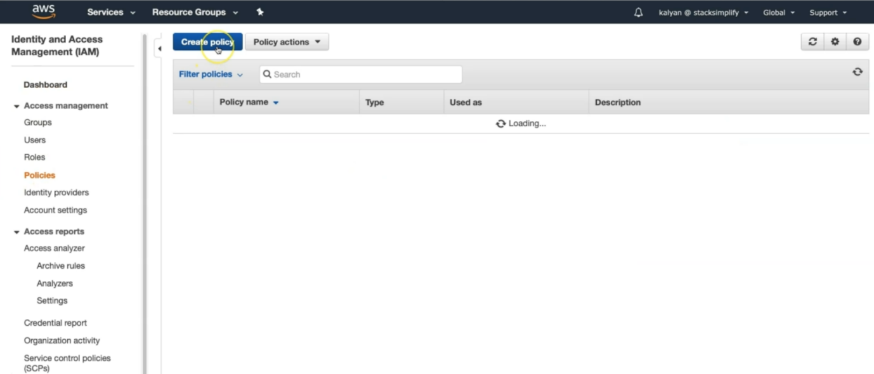

--- Select JSON tab and copy paste the below JSON.

{

  "Version": "2012-10-17",

  "Statement": [

    {

      "Effect": "Allow",

      "Action": [

        "ec2:AttachVolume",

        "ec2:CreateSnapshot",

        "ec2:CreateTags",

        "ec2:CreateVolume",

        "ec2:DeleteSnapshot",

        "ec2:DeleteTags",

        "ec2:DeleteVolume",

        "ec2:DescribeInstances",

        "ec2:DescribeSnapshots",

        "ec2:DescribeTags",

        "ec2:DescribeVolumes",

        "ec2:DetachVolume"

      ],

      "Resource": "*"

    }

  ]

}

--- Review the same in Visual Editor

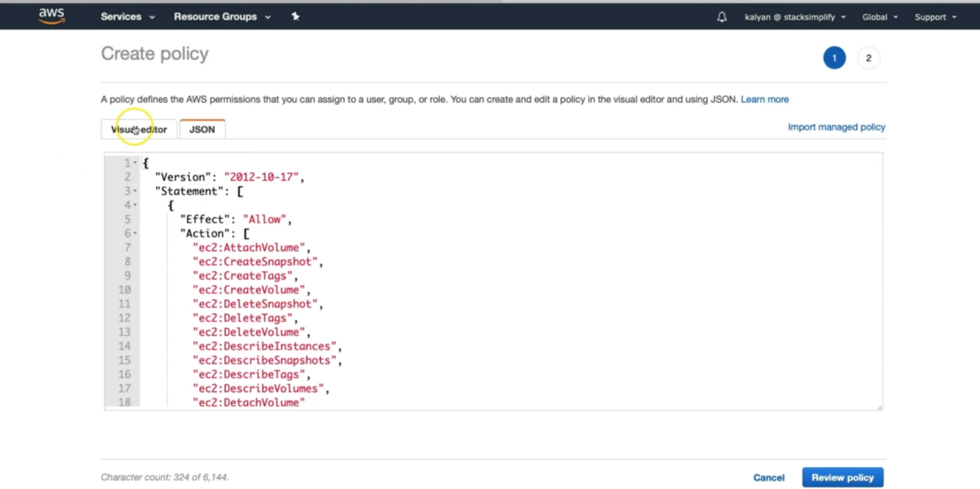

--- click on visual editor

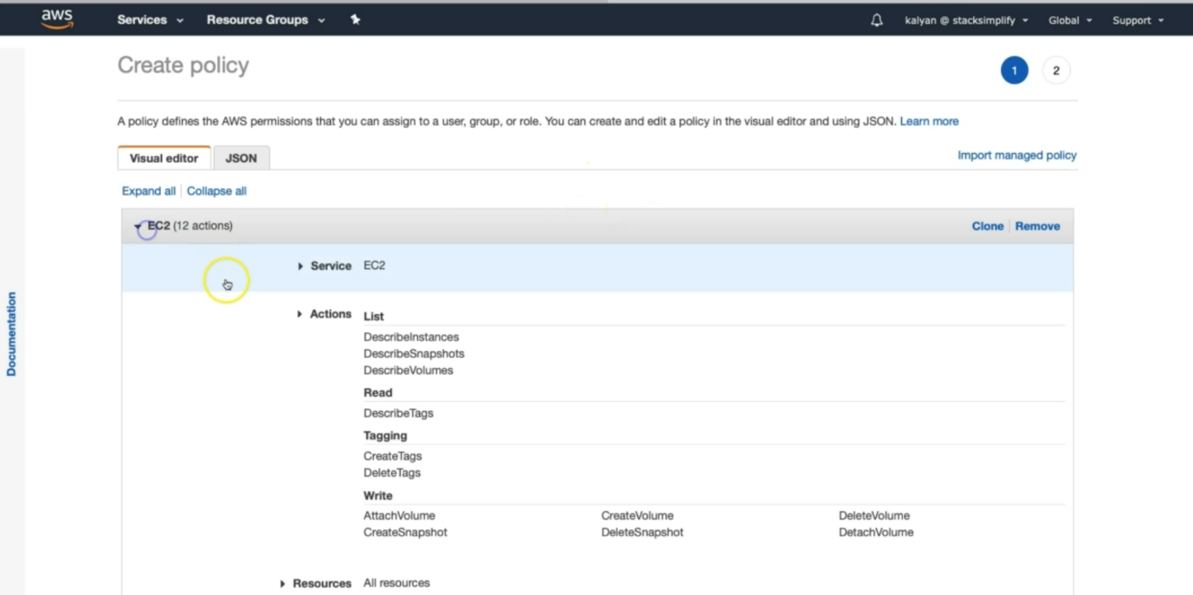

--- these are the ec2 actions, it is going to pick. As part of the whatever the json we copied.

--- Click on Review Policy

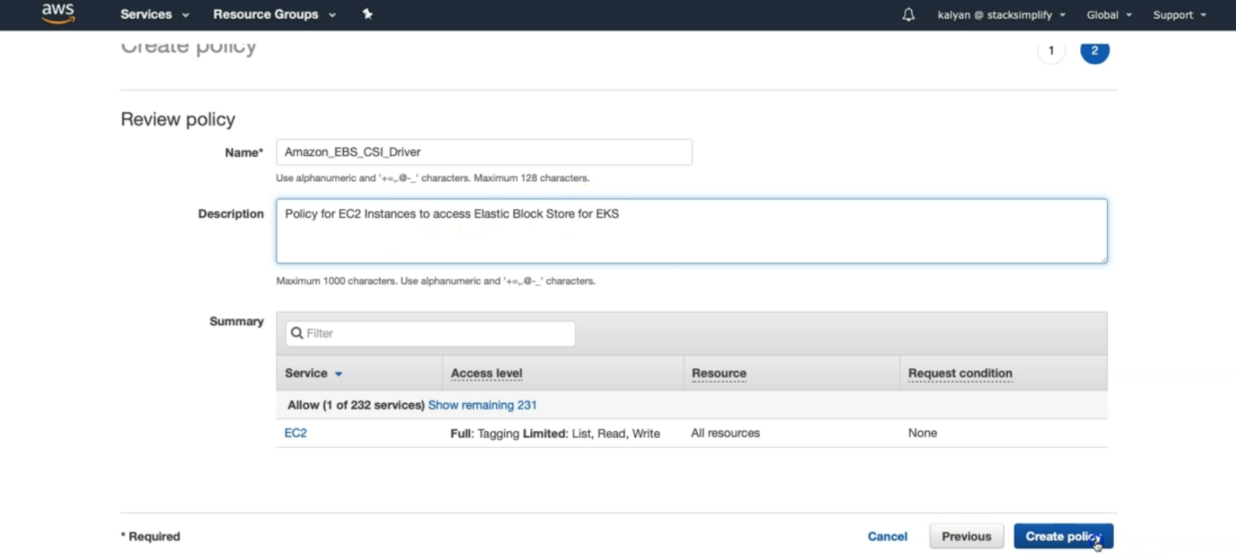

--- **Name**: Amazon_EBS_CSI_Driver

--- **Description**: Policy for EC2 Instances to access Elastic Block Store

--- **note** - Click on Create Policy, once the policy got created then do the below step.

**Get the IAM role Worker Nodes using and associate this policy to that role**

--- Go to Services -> IAM -> Roles

--- Search for role with name eksctl-eksdemo1-nodegroup and open it

--- Click on Permissions tab

--- Click on Attach Policies

--- Search for Amazon_EBS_CSI_Driver and click on Attach Policy

**# Get Worker node IAM Role ARN**

--- **kubectl -n kube-system describe configmap aws-auth**

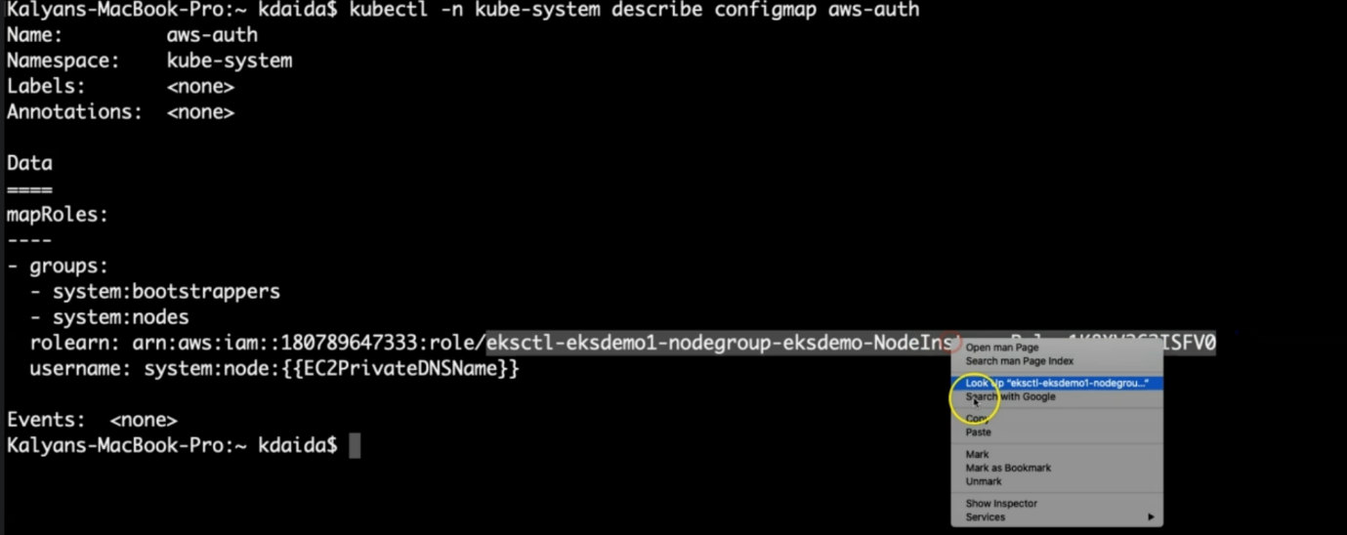

--- **note** – this is the role arn, it means that we have to search this name under IAM role.

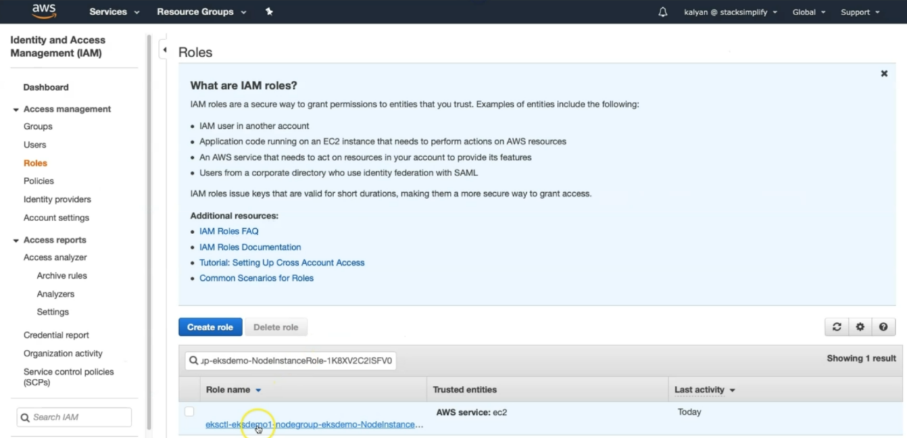

--- click on this role.

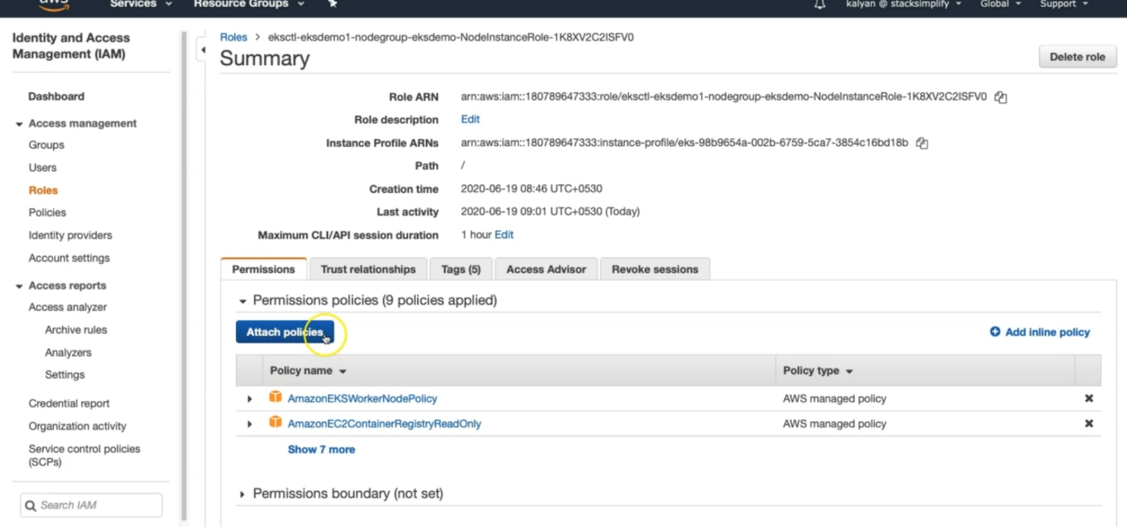

--- inside the role, we can attach the policy. Click on attach policy.

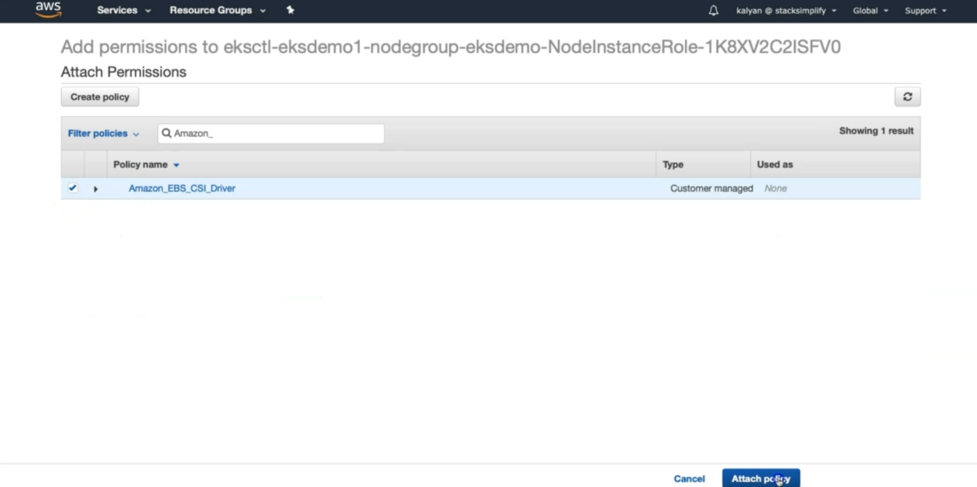

--- now search for **amazon_EBS_CSI_Driver** policy and attach it.

**# from output check rolearn**

--- rolearn: arn:aws:iam::180789647333:role/eksctl-eksdemo1-nodegroup-eksdemo-NodeInstanceRole-IJN07ZKXAWNN

**Deploy Amazon EBS CSI Driver**

--- Verify kubectl version, it should be 1.14 or later

--- **kubectl version --client --short**

**# Deploy EBS CSI Driver**

--- **kubectl apply -k "github.com/kubernetes-sigs/aws-ebs-csi-driver/deploy/kubernetes/overlays/stable/?ref=master"**

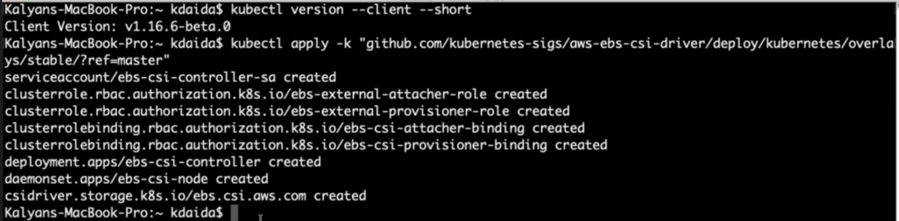

--- **note** – it will cluster rolls, daemons set..etc whatever it required.

**# Verify ebs-csi pods running**

--- **kubectl get pods -n kube-system**

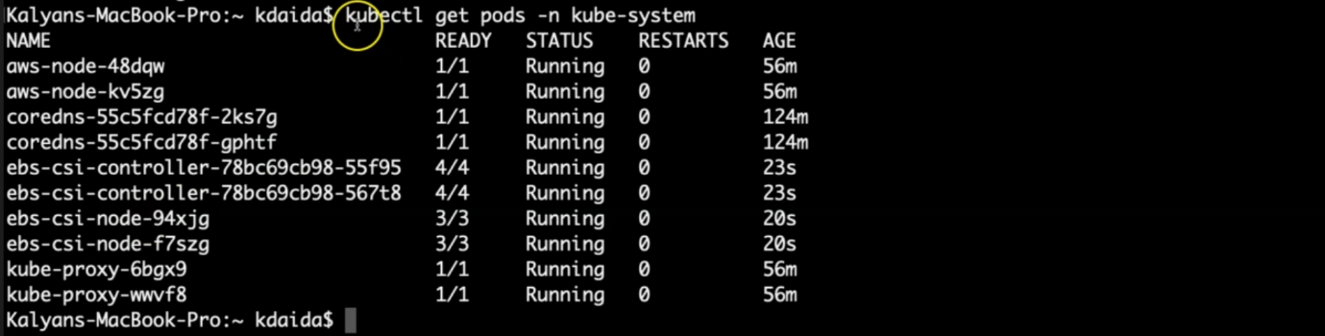

--- **note** – kubernetes created some pods related to ebs-csi-controller and ebs-csi-node.